Malicious Traffic Monitoring
- Overview
We will be focuses on capturing and analyzing malicious network traffic using Wireshark, a packet analysis tool. To simulate malicious behavior in a controlled lab environment, ARP spoofing is introduced. This creates an artificial attack scenario where one system impersonates the gateway to intercept packets.
- Objectives
- Understand Harmful Traffic Behavior
- Usage of Wireshark for threat detection
- System Requirements
- Two machines with Same Network Connection [Kali & Windows Machine]
- Step-by-step Implementation
Step 1. Enable IP Forwarding (to avoid disrupting traffic)
Run this Command in the Kali echo 1 > /proc/sys/net/ipv4/ip_forward
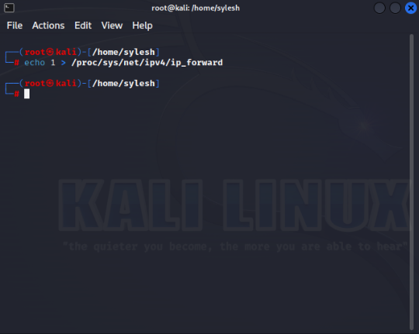
Step 2. Run this command arp-scan –localnet to know the target and gateway IP/MAC
- Target IP: The victim's IP (e.g., 192.168.182.138).
- Gateway IP: The router's IP (e.g., 192.168.182.1).
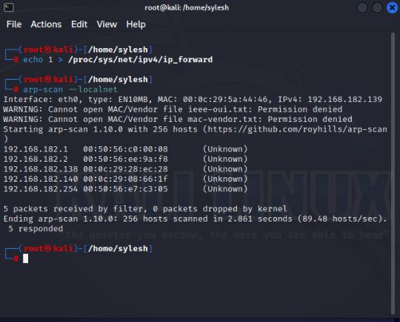

🔹 ARP Spoofing with Ettercap
Step 1: Open Application Search for Ettercap -graphical Click on the Ettercap-graphical click on the Tick Mark and wait until it runs
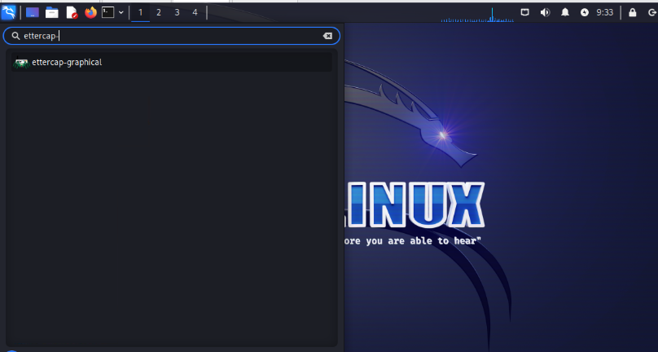
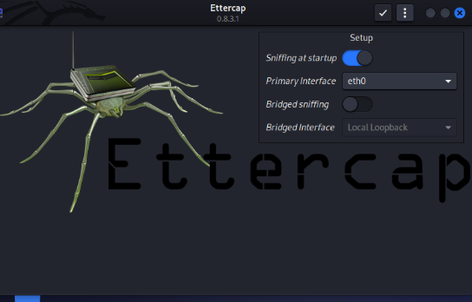
Step 2: Scan the Network for Targets

Run this Command sudo ettercap -T -q -i eth0
- -T → Text (CLI) mode
- -q → Quiet mode (only show important info)
- -i eth0 → Network interface

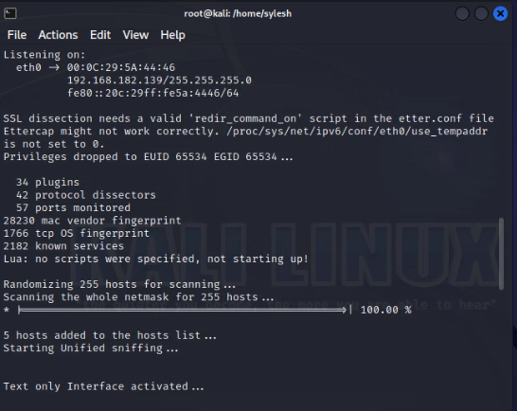

Step 3. Run this Command ettercap -T -i eth0 -M arp:remote /192.168.1.100// /192.168.1.1//
• -T: Text mode.
• -i eth0: Interface.
• -M arp:remote: ARP poisoning mode.
- /192.168.182.138// → Target IP (victim)
- /192.168.1.1// → Gateway (router) IP
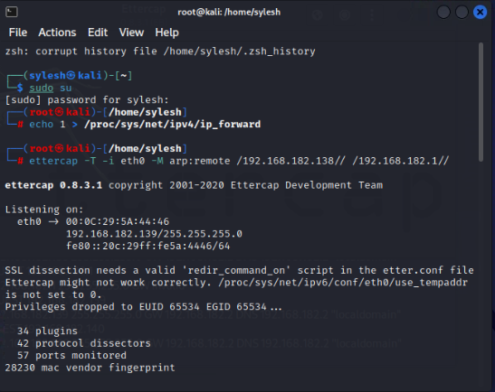
By the running the Above Commands, we performed the man in the middle attack, we are saying the target, we are the router
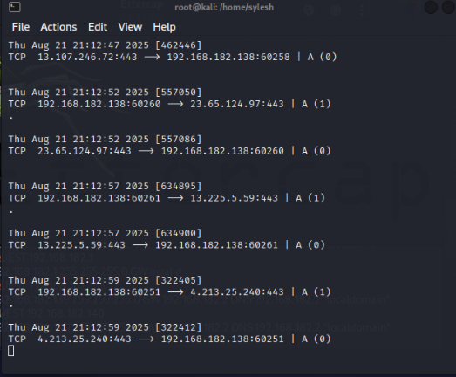

Step 4 Observing the Traffic using Wireshark
- Open Application Search for Wireshark Click on the Wireshark

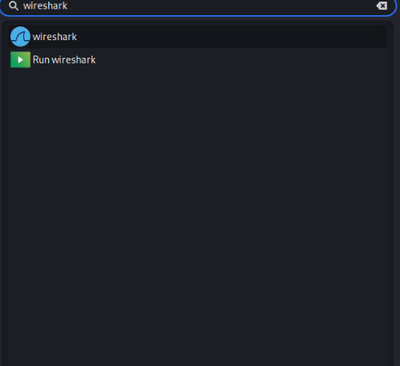
Step 5 Select eth0
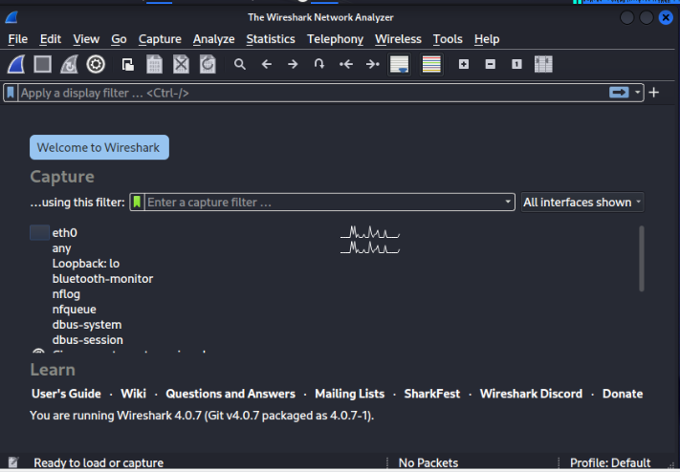
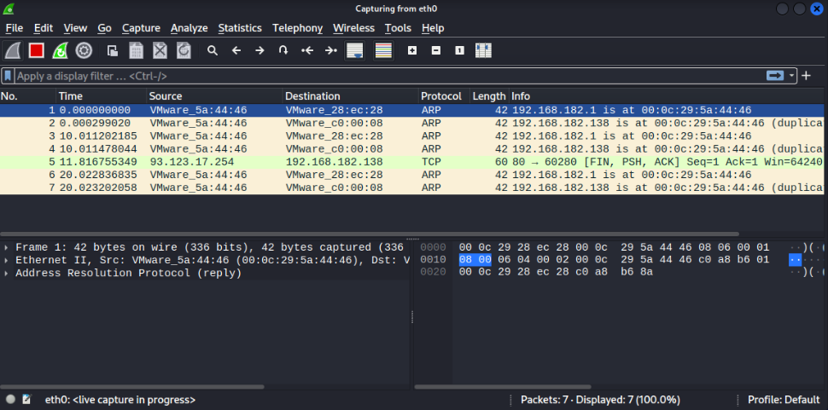

Step 6 : Filter ARP Protocol, observer the ARP flood, in target machine
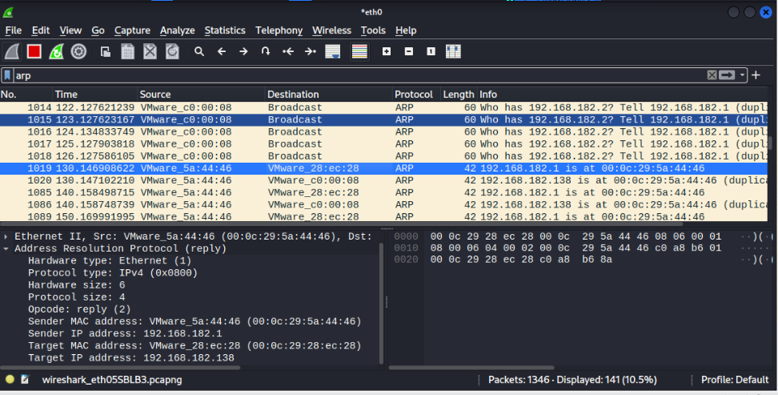

Step 7: Open browser in windows machine/your target machine and open some websites http/https and observer the data packets in your source machine using Wireshark

